|  |  |  |
| --- | --- | --- |
|  | | |
|  |  |
|  | | |

|  |  |
| --- | --- |
| 811 SW 6th Avenue, Suite 1000 Portland, OR 97204 503.200.6600 **www.rsginc.com** |  |

1.0 VisionEval 1

2.0 VisionEval Steps to Implement 2

3.0 Deliverables Summary 10

4.0 Budget and Schedule for VisionEval Model 10

Budget Assumptions 11

Schedule Assumptions 1

5.0 Sample RSG Visioneval projects 1

**List of Figures**

Figure 1: Role of the VisionEval strategic Model 1

Figure 2: Model Region 3

Figure 4: Applications of Strategic Models 1

# VisionEval

This document describes the background, scope and budget for deploying a Valley-wide VisionEval model platform for use by the MPOs in the San Joaquin Valley (SJV). VisionEval is a strategic model used by transportation agencies to create efficiencies in their travel modeling work and to expand insights in policy analysis. Agencies are using it as a tool to rapidly assess a wide range of policy alternatives and better understand the implications of their policy options. This approach quantitatively supports a more creative and robust policy discussion at the outset of the planning process. VisionEval also serves to efficiently identify a refined set of policies that can be further analyzed in a network model.

Relative to network models, VisionEval contains less engineering detail but is easier to develop and faster to run. VisionEval combines a disaggregate representation of the travel demand (i.e., households) with an aggregate representation of the transportation supply (lane miles by facility type, transit service miles). It is a complementary model to the travel demand model, not a replacement.

VisionEval uses a simplified modular model structure that enables the tool to adapt and evolve in ways to benefit from other adjacent models such as the ITHIM – Integrated Transport and Health Impacts Model. The disaggregate demand uses a household level synthetic population to attain socio-economic insights and support travel choice forecasting. Where agencies already have a synthetic population, such as with a DaySim travel demand model supported by PopulationSim, VisionEval can usually be configured to use those tool’s data, thus reducing development time and increasing the consistency between VisionEval and the regional travel model. Figure 1 illustrates the relationship that VisionEval has relative to the more common transportation travel models.

Figure 1: Role of the VisionEval strategic Model

Source: Oregon DOT adapted by RSG

# **VisionEval** Steps to Implement

The description below outlines the general steps RSG will follow for the development of one VisionEval model for the entire Valley.

* **Aligning Socio-Economic Data:** The VisionEval model will start by using the base year data from Census and other public sources. RSG will choose the best population synthesis approach to use given the quality of that data and synthesize the modeled population.
* **Geographic scale and resolution:** The VisionEval system has recently been used in high population areas such as Baltimore and Houston. The SJV’s size, variety of land use intensity, and diversity will require a large model application of VisionEval. The Long-Range Plan states, “While the SJV is largely rural in nature, it does contain several large cities and suburbs with a total population of a little over 4 million people. The eight San Joaquin Valley counties are a part of seven Metropolitan Statistical Areas (MSAs): Stockton-Lodi (San Joaquin County), Modesto (Stanislaus County), Merced, Fresno (Fresno County,Madera County), Hanford-Corcoran (Kings County), Visalia (Tulare County) and Bakersfield-Delano (Kern County).” The VisionEval model will be designed to cover the entire San Joaquin Valley (SJV), with a zone structure built upon the Census geographies designed to nest as much as possible within each County boundary.
* A **crosswalk between the eight MPO travel demand models’ TAZs and the VisionEval zone system** will support finalizing workable VisionEval zones and allow for any necessary translation between the travel models and VisionEval.

Figure 2: Model Region

* **Confirm analysis years:** The VisionEval model requires inputs for all analysis years. RSG will facilitate Valley MPO agreement on the desired baseyear (assumed 2023) and a future horizon year (assumed to be 2046for the moment). Data developed for the future baseline scenario will serve as a pivot point from which to develop future “action” scenarios and any desired intermediate years.
* **Collect data:** This step covers the range of data collection activities to inform the many inputs that the VisionEval model uses. RSG will source baseyear data from Census and public assets; the Valley MPOs will prepare the future (and any intermediate year) VE inputs themselves in one common horizon year (assumed to be 2046), with RSG assistance to standardize into the VE-required format. Other inputs regarding the types of vehicles registered may require assistance from the other COG and state agencies. This effort will likely require some assumptions and professional judgments since data may not be available for all years and all geographies.
* **Confirm modules and VisionEval packages:** As a modular software package there are various options available to bring new insights and analysis opportunities into the decision-making process. RSG assumes the following modules will be implemented:
  + **VEPopulationSim:** This is a powerful and necessary tool to incorporate US Census American Community Survey (ACS) variables and append them to the individual and household records. It can also be used to create alternative demographic scenarios for analysis.
  + **Working from Home**: The WFH module was built around observed travel behavior for those who are teleworking using data from RSG’s numerous rMove household travel surveys. The module uses the occupation of the workers (from BLS data) to assert a propensity to telework. The rate of teleworking is an input to the model and will then change the number of commute trips made by the individual.
  + **Health Module:** RSG developed a beta version of a VisionEval module to use the VisionEval model to estimate changes in avoided deaths due to changes in travel behavior. The Integrated Transport and Health Impact Modeling Tool (ITHIM) uses baseline health data for the specific geographic region to account for how exposure to air pollution, crash rates, and changes in active travel will change deaths in the population.
  + **Driverless:** RSG developed with FHWA support several enhancements to model the effects of highly connected human driven vehicle and fully autonomous self-driving vehicles. The vehicles can be owned by a household or considered as ride hailing vehicles. Transit and commercial vans can also be tested for how automation may affect VMT and transportation capacity of the system.
* **Housing and Land Use Allocation procedures:**
  + RSG will work with FresnoCOG staff to assess the best technical solution for incorporating a reasonably robust treatment of land use and household location. Given the size of the model region--8 counties and over 4 million people--finding efficient ways to apply alternative land use strategies will be an important consideration in this project. There are several possible options: manual scenario design using GIS to directly adjust baseline inputs to form different scenarios, new automated or semi-automated modules just now coming online for VisionEval or borrowing a separate land use allocation pre-processor proven to be successful in the SJV or another region with a similar population.
    - The standard (manual) process in VisionEval allows the user to specify at the TAZ level (i.e., Bzone in VisionEval) the number of multifamily, single family, and group quarter housing units. The user assembles and adjusts information such as population density of the zone (using the size of the zone and developable land area estimates), number of jobs in the zone, and network attributes such as walkability, intersection density, and transit frequency). VisionEval taps these inputs to establish during runtime whether the zone is part of a mixed-use neighborhood (a key predictor of travel behavior). Given that the zone structure can be borrowed directly from Census geographies, entering the “baseline” version of these inputs is often a straightforward process since MPOs typically already have an adopted baseline future land use encoded for use in their travel models. However, developing alternatives using this standard ‘manual’ process requires using additional tools such as ArcGIS to adjust, manage, and visualize the scenario inputs; and user judgement to appropriately render policy variations in model-ready form.
    - RSG recommends evaluating all other possible approaches relative to a beta version of a new VisionEval Land Use recently developed by Portland State University. The new process is designed to offer regions that have less prescriptive land use controls the flexibility to explore divergent futures with a level of control appropriate for the jurisdiction. The new module provides two additional tools *beyond* the standard manual method for managing the land use allocation process during “action” scenario preparation:
      * + User assigns general plan designations using land use types or place types to VisionEval Bzones. Then a subroutine model allocates jobs and housing to Bzones using the typology as an attractiveness factor. This gives the user a moderate level of zonal level control.
        + User specifies land use policies that the model itself uses to assign land use types, after which the model repeats the household and employment allocation by typology. This provides users the least amount of direct control over the final allocation with the advantage of needing to specify only policy inputs (which are equivalent to zoning).
    - Alternative pre-processors or other processes can be used to evaluate housing choice and land use options and then translate those options into the structure that VisionEval requires. One possibility is the combination of a population synthesizer used for activity-based travel models (ABMS) such as FresnoCOG’s and a “parcelizer” application RSG developed for ABM applications needing land use scenario creation/manipulation. FresnoCOG already has some of these pieces given both agency staff and RSG prior work on the regional travel model; these tools could perhaps partly automate the “manual” approach described above.
    - RSG will work with FresnoCOG staff early in the project to assess these options and choose the best toolkit. Criteria should include scalability (ability to cover the SJV geographic and population size), data availability (the presence and consistency of future baseline land uses from the various participants and Census sources), and usability (capability of the tool to create the necessary scenarios quickly and at sufficient quality). RSG anticipates that the VisionEval modules enhanced by Portland State will provide reasonable performance with a level of confidence in the various land use permutations while also fitting within the time and budget constraints.
* **Develop baseline models:** RSG proposes to set the baseyear to a recent year for which needed Census data is available, giving the Valley MPOs a range of possible specific choices. This task will establish one (1) base year and one (1) future baseline (aka “future reference scenario”) to which all other scenarios can be compared during application, e.g., to understand changes in travel behavior, land use, and transportation emissions. The future reference inputs, as mentioned above, will come from the eight Valley MPOs. RSG assumes that the future reference will represent, collectively, the adopted MTPs and supporting land uses from the MPOs.
* **Calibration, Validation, and Sensitivity Testing:** No model is ever a perfect representation of travel behavior. However, a model should adequately reflect current conditions to reliably estimate outcomes of interest with sufficient sensitivity to input dimensions. Calibration includes the effort to accurately represent the baseyear. VisionEval was estimated from readily available national data such as the National Household Travel Survey (NHTS) and the ACS. On the validation side, several outputs from the VisionEval model will be compared to empirical data (typically BTS LATCH). Validation shows how the model does to reflect other historical years. Sensitivity testing illustrates the model’s responsiveness to changing specific input dimensions by identifying the resulting changes in outputs. Typically, RSG tests 25% changes in several inputs (i.e., transit supply, roadway miles, fuel prices) to explore elasticities in the changes of selected outputs. RSG will work with FresnoCOG to specify one Valley-wide sensitivity test scenario, run it, and visualize the results.
* **Multiscenario analysis and interpretation:** Evaluating VisionEval results uses both tabular and graphical methods to summarize and present the forecast outcomes. A primary objective will be to enable Valley MPO staff to use VE in its exploratory, Multiscenario mode to identify key relationships between specific inputs and desired outcomes. This will allow Valley decision makers to make policy choices with confidence.
* **Visualization:** An interactive visualizer will be provided to communicate model results both spatially as well as in tables and charts. VisionEval summarizes data at the household level which can be aggregated to sub-Valley geographies, Counties, and the entire modeled region. The synthetic population can also be used to summarize and visualize data across certain sub-populations such as income groups, rural/urban locations, age groups, household groups by vehicles owned, etc. RSG can provide different types of visualization platforms--open source rShiny tools, PowerBI and Tableau are options—and RSG will assist FresnoCOG in understanding which platform will best serve. After choosing the platform, the RSG team will produce and maintain (until the end of the contract) a visualizer for summarizing inputs and outputs (note that RSG recommends a Shiny application). A beta version of a visualization can be found at <https://rsginc.shinyapps.io/bmc_input/>and in the figure below.

* **Documentation and Training:** For the final tasks RSG will document the process from model design through input development, how to develop scenarios, and how to use the SJV VE model. RSG will also provide training for Valley MPO staff and transition model stewardship to FresnoCOG. The training will describe how individual MPOs can use the County-wide model for local analysis. The documentation will be packaged as one draft and one final version (addressing one set of client comments on the draft). It will include a summary of the inputs for the base and future years, the sensitivity scenario design, and the results from the validation and sensitivity test. While this material can be packaged in static PDF format, RSG assumes using an online ‘wiki’ for maximum accessibility and for easy maintenance (see an example of using VE for climate modeling in Oregon at<https://orscenplg.github.io/VEWiki/index.html>).

#### Process Map

The figure below shows the typical process for a VisionEval scenario evaluation. Initially, the core VisionEval model is designed to reflect historical base years and future reference years. The inputs are often provided from a regional travel model or other sources of data. A scenario analysis process considers a wide range of possible drivers of change that can alter travel behavior and land use in the region. The drivers of change then are combined to create a large domain of possible futures – called the Cone of Uncertainty.

By evaluating both inputs and outputs from the many hundreds of possible outcomes a refined set of scenarios can emerge that may provide the region and any sub-regions, insight that they otherwise wouldn’t get from the application of the detailed, robust, yet time intensive Daysim regional travel model.

Starting with a common socio-economic basis by using the same synthetic population as the regional travel model creates alignment between the tools to leverage the strength of each (VisionEval and Daysim) for their strengths and benefit from the unique attributes and performance measures produced by both tools. Note that this contract does not include regional travel model runs; RSG assumes that the existing baseyear and future reference year data from the regional model are “ready to go.”

# Deliverables Summary

For quick reference, this section summarizes the deliverables RSG will provide:

* San-Joaquin Valley-wide VisionEval model (the “SJV VE”) calibrated and validated in one baseyear and run for one future baseline year, stored on GitHub.
* SJV VE input data files for one baseyear, one future baseline year, and one future sensitivity test.
* SJV VE model runs (output files) for the baseyear, a future baseline, and a future sensitivity test (Land use and transportation variations).
* Written documentation (one draft and one final version) of the SJV VE model, its methodology, its validation, and its baseyear and future baseline input data; in an online format.
* A web-accessible dashboard visualizing selected SJV VE inputs and outputs, implemented so that the user can select the model runs shown and display results at the Valley-wide, subarea (North, Central, and South), or single county levels.
* RSG staff support to present at up to three stakeholder meetings in addition to the standing project management meetings.
* Eight contact hours of training, delivered remotely to all participants simultaneously. Includes training guide slide decks and final edits to the documentation prompted by questions during training.

# Budget and Schedule for VisionEval Model

The cost estimate tabulated below includes the development of the core VisionEval model, customizing the model with modules relevant to the SJV including a means of handling housing/land use scenarios, documentation, visualization of both inputs and outputs, plus training and installation assistance.

The budget for developing and applying a VisionEval RSPM for the SJV geography reflects the approach outlined above along with several assumptions listed below.

### Budget Assumptions

* Project Management. The RSG team will hold and distribute notes for bi-weekly conference calls with FresnoCOG to discuss progress in the previous period and issues that may arise. RSG will prepare monthly invoices and progress reports.
* RSG will source, collect, clean, and create VE inputs for one common baseyear using Census and other public sources. Choice of baseyear can be any year for which such data is readily available.
* RSG will collate inputs and run one future reference year – assumed to be year 2046.
* Geographic extent will be the entire San Joaquin Valley, with the VE zone system designed to nest as closely as Census geographies permit within each of the 8 counties.
* The VE model will include the latest VE 3.1.2 core framework, supplemented with modules developed by RSG including, VEPopulationSim, Teleworking, Driverless Vehicles, and VE-ITHIM. RSG will choose the best population synthesis approach after collating the baseyear data. RSG also assumes that the housing and allocation steps will be performed using the new modules from Portland State University or equivalent means requiring no extra budget beyond that included herein the scope.
* The VE zone structure will be driven by Census geographies, and a crosswalk table provided between the Census geos and the MPO models’ TAZs.
* Calibration of the model will be done to one historical base year. The calibration will attempt to balance daily VMT per capita or household at the Azone level that aligns with BTS LATCH data. Total daily network VMT, vehicles owned by households, vehicles per capita, income distributions, walking, biking, and transit trips all will be measured against data from the BTS LATCH or other readily-available sources. Efforts to calibrate vehicle DVMT will be the priority. If other parts do not calibrate, they will be informative regarding the capabilities of the model.
* A screenshot of a graph

  AI-generated content may be incorrect.Scenario analysis will be enabled by the core VE Multiscenario analysis approach. This packages up a set of inputs and creates a set of unique combinations, supporting running hundreds of input combinations and evaluating the results against user-set performance measure targets (up to six measure targets at a time). The Multiscenario viewer/evaluator can be created in Tableau or in Shiny .<https://public.tableau.com/app/profile/charles.baber/viz/BMC02012025_v3_11/Dashboard?publish=yes>
* The outputs visualizer will be built in Tableau or Shiny.
* If sub-regions want to create smaller, sub-region models, that can be explored after the conclusion of this project.
* There are several items that this scope assumes FresnoCOG and the Valley MPOs will provide:
  + Common future horizon year (assumed 2046) socio-economic and land use TAZ-level input data from the 8 regional travel models covering the desired Valley-wide VisionEval model geography and VisionEval zone structure; plus the baseyear and future year transportation networks for the road and transit transportation systems from the regional travel models (or equivalents) sufficient to compute total roadway lane miles and total transit service miles for the Valley-wide VisionEval model geography.
  + Baseyear regional travel model forecasts showing mode shares, VMT, and VMT/capita from each of the 8 models (can be in different baseyears).
  + TAZ polygon spatial data files for the 8 MPO travel model zone systems, and review of the VE zone to MPO travel model crosswalk table.
  + Scheduling, facilitating, and supplying notes for any stakeholder engagement required (RSG will provide supporting material through the RSG deliverables summarized above).

Table 1 summarizes the key tasks and the estimated fee by task.

Table 1: Task Budget

|  |  |  |
| --- | --- | --- |
| Task | Description | Fee |
| Project Management, QC, and engagement support. | Biweekly meetings with agendas and notes, monthly progress reports and invoices, change management, and QA/QC. RSG staff presentations (one slide deck) for up to three general stakeholder meetings. | $19,110 |
| Set up VisonEval for one Valley wide geography | GitHub repo and VE model setup. Incorporate VE Framework updates, set up and function test base model.Install the custom VEPop Sim, VE ITHIM, Driverless, and WFH modules. | $39,900 |
| Implement a VE Land Use and housing choice module. | Assess options and implement best tool (assumed to be the new VE LU module). Validate the LU module in the chosen baseyear for the Fresno geography; finalize parameters for Valley-wide application. | $100,800 |
| Assemble data inputs and model parameters for base and future year(s). | Establish valley-wide zone structure starting from Fresno ABM TAZs, source and obtain baseyear data from Census and public info, set up and feed the VE population synthesizer. Establish Census-TAZ crosswalk for all MPO model geographies. Coordinate with the 8 MPOs to tap regional travel model socio-economic, land use, and transport inputs for one common future year baseline (assume year 2046). Collect future baseline data from all 8 MPOs, clean and standardize into the future baseline VE input data format. | $168,000 |
| Calibrate the VisionEval model for the Base Year | Confirm VE performance measures and historic year to use for calibration/validation, choose validation metrics (e.g., VMT, transit, walking/biking, etc.), iterate runs/adjustments to calibrate. | $33,600 |
| Design and implement the visualizer. | Deploy web-accessible means of visualizing and sharing key findings. Will allow filtering to three levels: valley-wide, three main subareas (north, central, and south), and (individually) each of the eight counties. | $29,400 |
| Design and run a future year scenario for sensitivity testing. | Design future LU inputs (transport inputs optional). ID VE outputs most relevant to the test. Run the test, report and interpret results using the visualizer. | $39,900 |
| Document tool implementation process, inputs and source data, calibration/validation results, and base and future scenario outputs. | Written documentation with chapters explaining model geography, inputs, calibration and validation, and outputs. Documentation includes GitHub repo management with core software to align with FHWA and a custom repo with the FresnoCOG installation and description of the Valley inputs. | $29,400 |
| Train 8 SJV COGs staff in the development, use, and maintenance of the model/tools including training in R for VisionEval. | Training on GitHub management to update software packages, install and build VE installations. Training with guidance (provided via Video and PPT) on installing, customizing inputs, running, and extracting results. Key R commands and helper scripts can be provided. Assumes 8 contact hours, slide decks to guide the training, and updating the documentation based on questions received during training. | $39,900 |
|  |  | **$500,010** |

### 

### Schedule Assumptions

The project will require six calendar months to complete. The schedule below assumes a July 1, 2025 NTP and completion by December 31, 2025. The schedule would need to be adjusted if NTP occurs later.

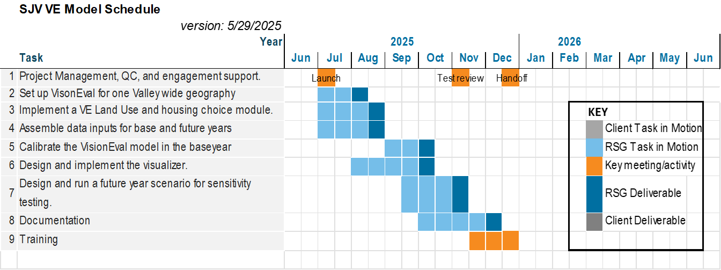

# Sample RSG Visioneval projects

VisionEval is an open-source software that RSG has been actively working with, but it is licensed to be freely available and able to be run on Windows systems using R software. RSG did not create the software, but the firm contains national experts in the design, development, and application of it.

#### Known Applications of Strategic Models

Figure 3 shows the known applications of strategic models in the US that include both statewide DOT applications and regional, MPO, applications.

Figure 4: Applications of Strategic Models

Source: RSG

The following summarizes several of the development and application efforts that RSG has been involved regarding strategic models.

##### Baltimore Metropolitan Council

RSG is the lead technical subconsultant supporting BMC in their scenario planning process prior to a long-range plan update. RSG assisted the MPO in the development of VE inputs to calibrate the results of the VE model to align with recent travel behavior surveys. RSG developed a run script to use the Teleworking module and the Driverless vehicle modules. RSG developed a Tableau interface to enable the MPO to explore the results of hundreds of model runs. RSG also assisted develop a configuration script to create 1500 unique scenarios and run those scenarios on Virtual Machines. RSG assisted with queries to extract key performance measures from the model runs and display the results for analysis. The VisionEval is coordinated to account for housing and transportation costs and then used in a manner that can inform the InSITE Activity-Based Model.

##### FHWA Pooled Funds

RSG was the lead technical subconsultant who performed the R scripting and tasks for the FHWA Pooled Fund supporting the continued growth and development of VisionEval. The three-year contract concluded in 2022 included tasks associated with improving user documentation, creating scripts to partially automate inputs, improving the use of local data in the estimation process, creating outputs for equity analysis, developing a mechanism to transfer externally produced synthetic population into VisionEval, and developing a linkage to stand-alone health models (e.g., ITHIM). RSG updated the GitHub website and created the user guide at <https://visioneval.github.io/docs/>

##### CCPRC Strategic Planning Model

RSG applied the VisionEval Regional Strategic Planning Model (VisionEval-RSPM) in the northwestern corner of Vermont which was used to evaluate a wide range of policy and pricing investment scenarios as part of an early planning effort before the next update to the long range plan. The model developed a synthetic population calibrated to income, household size, and vehicle ownership rates, and estimated daily household VMT for the six-county region. The tool evaluated effects of significant shifts to active travel modes, increasing transit access, land use density and diversity, ride hailing accessibility, and various pricing options to efficiently identify a range of possible futures and goal seek which strategies lead to desirable future outcomes. Two different land use strategies were included and all scenarios were evaluated using the multirun scenario viewer as well as a TMIP-EMAT application. The effort led to a Transportation Demand Management investment ‘bundle’ that is informing subsequent investigations to identify the investments necessary to implement and achieve these VMT reductions.

As part of the RSPM application, RSG created a visualizer summarizing data at the household level. The purpose of the tool is to summarize and visualize the disaggregated household output data from VE-RSPM modeled scenarios. The summary data tab summarizes individual household records from the scenarios and allows the user to interactively select different household characteristics (personas) and observe key summary metrics. The map tab displays the same household-level data but averaged and displayed geographically at the TAZ level. This allows the users to observe average spatial differences between the various model scenarios. If desired, the user can download a shapefile of these map layers for their own analysis or display. <https://rsginc.shinyapps.io/CCRPC_HH_Explorer/>

A second phase of the project created the first ever linkage to a trip-based travel demand model. Using the preferred scenario investments from the Strategic Model, a zone by zone change in daily VMT was translated to a trip generation rate in the assignment model. The innovative linkage allowed the Strategic Model policies to be directly modeled in the assignment model and more readily observe volume and operational effects on the transportation network.

##### Incorporating Automated Vehicles into Scenario Planning Models (VisionEval-RSPM)

RSG, as a subconsultant, led the design and implementation of model enhancements to incorporate Level 3-connected vehicles with advanced driver assistance systems and Level 5-connected autonomous vehicles in a VisionEval strategic model. With an understanding that there is 'deep uncertainty' as to the timing and manifestation of automated vehicles, the approach looks to develop scenario planning capabilities using the Vision Eval strategic modeling platform. RSG had the lead role in designing the improvements that can be incorporated into VisionEval models as well as leading the code development. The project was research-based, identifying what households may be eligible to use an advanced vehicle, what share of VMT may occur in these vehicles, and how the capacity of the transportation system is affected by the magnitude of driverless VMT in the system.

RSG was the technical lead in developing a module in VisionEval to account for how driverless vehicles may affect demand for travel and changes in the capacity of the transportation network. RSG produced a set of packages for VisionEval that accounted for new models of propensity to share vehicles, interest in using Level 5 fully self-driven vehicles, and a new set of vehicle types in VE including Level 3, fully connected, but human-driven vehicles and Level 5 – full self-driving and autonomous. Inputs can include dead-heading settings, parking fee avoidance, costs of vehicles, capacity changes, and changes in market share.

##### Oregon VisionEval Support (VisionEval-RSPM & VisionEval-STATE)

RSG has provided on-call support to Oregon DOT with the development of specific enhancements to VisionEval using a standalone VisionEval fork. The project’s efforts established and implemented a contributor review team to test and accept code developed into the VisionEval project using incremental steps to design, code, implement, and test. RSG assisted with the transfer of the statewide GreenSTEP strategic planning tool to the VisionEval framework (VisionEval-STATE).

RSG helped develop and deliver an in-person VisionEval training session and a knowledge transfer session with FHWA and the pooled funds contractor. RSG has continued this support more recently by developing driverless vehicle software enhancements that allows non-drivers to become occupants in automated vehicles, creatinginput files for putting occupancy values into shared and automated vehicles, and creating driverless modules within the VisionEval framework. RSG built an Oregon specific wiki focused providing practitioners the step-by-step guidance on how to develop and use a VisionEval model.

##### Oregon Transportation Plan – Scenario Analysis

RSG, as a subconsultant, led the scenario planning, modeling, and analysis tasks and informed the equity tasks as part of the Oregon Transportation Plan (OTP). The study was a significant update with several working groups and tasks over two years. The RSG tasks included determining the analysis approach, setting the outcome and goal areas, and defining the performance measures toward desired outcomes. RSG applied the VisionEval – State (VE-State) strategic model, implemented additional enhancements including creating a fiscally constrained modeling environment, updated data to the latest NHTS data, introducing a teleworking module, assessed automated vehicle demand, and improved visualization and reporting of the results. RSG also applied the TMIP-EMAT metamodel approach to multiple scenarios. The process used Exploratory Scenario Planning (XSP) to identify 13 dimensions which would be tested in a VisionEval model to identify which resulting outcomes would best deliver the goals identified through the public visioning and goal-setting process of the Oregon Transportation Plan (OTP). The XSP approach paired with the Exploratory Modeling and Analysis Tool enabled hundreds of future combinations to be tested and from that domain of futures, the ones which met the goals of the OTP were identified as preferable to pursue in implementation. The plan was novel by using VisionEval and EMAT in a statewide plan as well as being fiscally bound to account for changes in revenue as VMT changes due to pricing policies and other TDM measures.

The scenario planning and analysis work conducted by RSG were fundamental inputs to the development of the long-range plan by focusing on the results of various investment options and how best to achieve the stated goals of the plan. Two phases of EMAT modeling included focusing on Levers in Phase 1 and then exogenous uncertainties in Phase 2 to derive resilient strategies. See a recent presentation at: <https://www.youtube.com/watch?v=liXtldO2L-w>

##### New York State Clean Energy Roadmap (VisionEval-STATE)

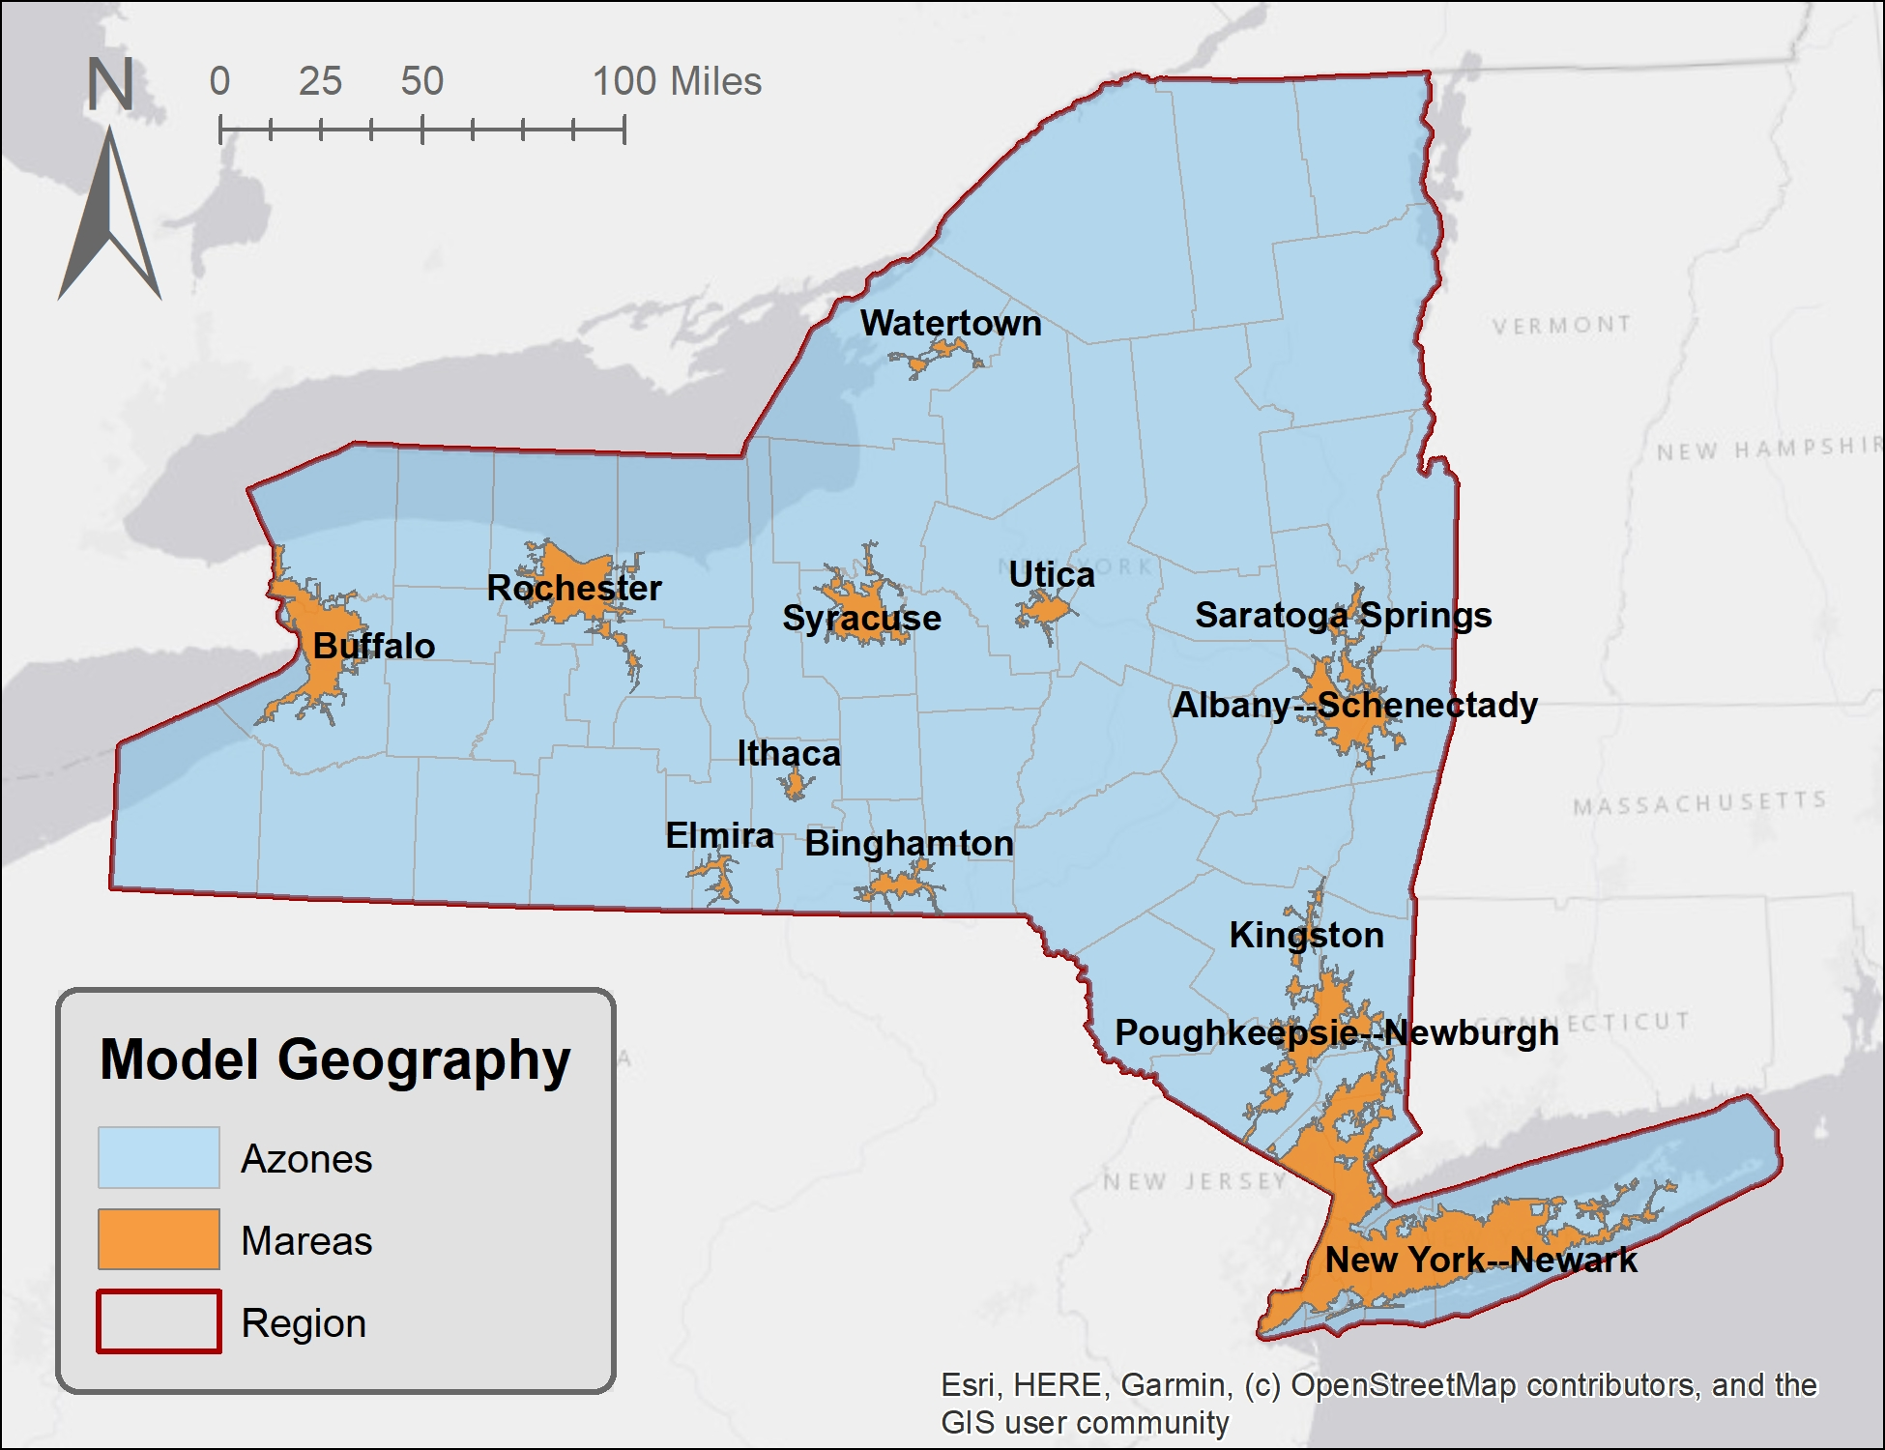RSG developed a VisionEval-State model for the Clean Transportation Roadmap for the NYSERDA. RSG designed the zone structure and census inputs and developed a calibrated VE-STATE model. RSG applied the model to test various scenarios of changes in EV market penetration, as well as how other policies may affect the adoption of electrification. The model accounts for other transportation and land-use investments and provides summaries of fuel consumed (including electricity) and VMT, as well as output segmented by income group to evaluate equity impacts.

Massachusetts 80x50 Modeling (EERPAT)

Under contract to the USDOT Federal Highway Administration, RSG developed the Energy and Emissions Reduction Policy Analysis Tool (EERPAT) in 2012. EERPAT is a strategic planning model for state DOTs to develop policies to reduce transportation greenhouse gas emissions. Through an engagement with FHWA, RSG implemented EERPAT models for Utah, Colorado, Washington, Maryland, and Vermont. RSG is actively building an EERPAT model for New Mexico and a statewide model for the New York State Energy Research & Development Authority using a tool within the same model family.

Building on this history and as a national leader in this space, RSG was an integral part of the development and application for the implementation of EERPAT in support of Massachusetts’ Executive Office of Energy and Environmental Affairs 80 x 50 effort, which is a planning process to reduce greenhouse gas emissions by at least 80% by 2050 in equitable and cost-effective ways. EERPAT was chosen as the best available tool to support understanding the complex decisions around travel choices and their emissions and energy impacts given a household’s characteristics including income, vehicle availability, household size, age of household members, community density, travel cost, and available travel alternatives. RSG was brought to the project having a successful history of other EERPAT applications to ensure the model was calibrated to the correct conditions and develop the appropriate input files. RSG also trained others to use EERPAT to broaden the population of capable users of the model. This model is now available to use as a policy tool for climate action policies and other policy scenario purposes beyond the 80 x 50 project.

Not only has RSG been an integral part of the development and application of the EERPAT model used in the Mass 80x50 study, RSG has developed complementary and related tools including the Rapid Policy Analysis Tool (RPAT), Impacts 2050, and the next generation model platform VisionEval.

##### Burlington, Vermont, Net Zero Energy Plan (VisionEval-RPAT)

RSG assisted the Burlington Electric Department (BED) develop a roadmap for how the city of Burlington can become a “net zero energy” (NZE) municipality. As envisioned by city leaders Burlington’s push toward becoming an NZE city means displacing fossil fuel consumption in the electric heating and transportation sectors using renewable energy sources. BED has already started the process of incentivizing a consumer shift toward more energy-efficient and sustainable technologies (e.g., incentivizing the purchase of electric vehicles for customers).

RSG developed a VisionEval-RPAT for the greater Burlington area of Vermont to evaluate various land use and transportation investment decisions as to how to reduce the overall demand for travel. Shifting to walking, biking, transit, and teleworking are the highest priorities for the city. The model was used to test mileage-based user fees, carbon fees, and transit investment. The highest return investments supported greater intensification of land uses but also carbon fees.

##### NY State Strategic Modeling for two MPOs (VisionEval-RPAT)

RSG worked with the New York State Energy Research and Development Authority, the New York State Department of Transportation, and two metropolitan planning organizations (MPOs) on the use of the Rapid Policy Assessment Tool (RPAT). The Capital District Transportation Committee and the Ithaca-Tompkins County Transportation Council were selected as the MPO clients. RPAT is an open-source strategic model designed to analyze the outcomes of multiple policy scenarios that involve changes to land use and transport fleet and usage. As a regional tool, it provides high-level results useful for an MPO’s long-range transportation plan analyses. During the course of this project, RPAT was converted to the VisionEval platform that is being actively supported by FHWA and AASHTO. Consequently, the MPOs have a tool that will be well-supported into the future and to which enhancements are likely to be made by the user community. Each MPO was supported in the development of data input files and model calibration. They installed the model and were trained in its use. They were then supported in running five scenarios of their own choosing; these included different land-use patterns and varying levels of electric vehicles in the fleet.

##### SHRP2-C16 Software Enhancements for RPAT (a.k.a. VisionEval)

RSG assisted the American Association of State Highway Transportation Officials Federal Highway Administration and Oregon Department of Transportation with the design implementation and management of VisionEval, a new framework for disaggregate strategic planning models. This open-source R-based modeling framework combines the implementation of the GreenSTEP family of strategic models: GreenSTEP Regional Strategic Planning Model (RSPM) and Rapid Policy Assessment Tool (RPAT). RSG managed the collaborative software development effort in GitHub. The RSG team finalized the VisionEval framework and integration plan for merging RPAT and RSPM via a set of common R modules/packages. RSG also reimplemented RPAT under VisionEval, developed an RShiny-based application for running VisionEval models, and integrated and updated the scenario viewer (visualizer) to work with VisionEval models. RSG set up continuous integration testing of software resources using TravisCI and developed and maintained the VisionEval user and developer documentation with markdown and wiki technologies.

##### FHWA, AASHTO – SHRP2 C16 Implementation Assistance (RPAT)

As part of the SHRP2 research program for FHWA and AASHTO, our team members updated the strategic planning tool SmartGAP to RPAT and provided technical support to MPOs implementing the model. The project included updates to the user guide, including guidance on calibrating the model to local observed conditions, development of a one-page quick start guide, development of a tutorial, and outreach at SHRP2 peer exchanges and workshops ([https://planningtools.transportation.org](https://planningtools.transportation.org/)).