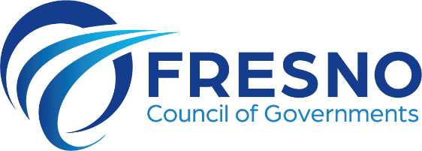
2035 Tulare St., Ste. 201 tel 559-233-4148
Fresno, California 93721 fax 559-233-9645
www.fresnocog.org

Policy Advisory Committee
MINUTES
Friday, November 14, 2025
10:00 AM

The meeting was held at FCOG Sequoia Conference Room.

Andrew Haussler, City of Clovis

Pio Martin, City of Firebaugh

Nicholas Mascia, City of Fresno

Virginia Penaloza, City of Huron

John Jansons, City of Kerman

Alexander Henderson, City of Kingsburg

Cristian Gonzalez, City of Mendota

Nicole Zieba, City of Reedley

Elizabeth Cabrera, City of San Joaquin

Paul Nerland, Fresno County

Braden Duran, Caltrans District 6

Robert Phipps, FCOG

Moses Stites, FCRTA

The meeting was called to order at 10:03 a.m. by Mr. Jansons (Kerman), Chair. With 10 members present, there was a quorum to conduct business.

JOINT Transportation Technical/Policy Advisory Committee

- Caltrans Report (Caltrans) [INFORMATION]

Braden Duran reported on the following:
- SR 99 Multimodal Plan report published.
- Mendota Roundabout

- TRANSPORTATION CONSENT ITEMS

A. Executive Minutes of October 10, 2025 [APPROVE]
B. FY 2025-26 First Quarter Report (Les Beshears) [ACTION]
C. Fresno COG 2024-25 Financial Audit (Les Beshears) [ACTION]
D. Obligational Authority Quarterly Report (Blake Rincon) [INFORMATION]
E. 2026 Meeting Calendar (Robert Phipps) [ACTION]

- Mr. Jansons called for any items wishing to be pulled by members or by the public.
- After an opportunity for public comment, Ms. Cabrera (San Joaquin) motioned, and Mr. Haussler (Clovis) seconded to approve the consent agenda items A-E as presented.

All in Favor, no opposed.
Motion passed.

- TRANSPORTATION ACTION/DISCUSSION ITEMS

- Regional Pavement Management System Update (Pankaj Joshi) [ACTION]
Summary: A well-maintained pavement management system is essential for monitoring pavement conditions, tracking rehabilitation history, and prioritizing maintenance projects to optimize funding allocations.

In July 2024, Fresno COG selected Nichols Consulting Engineers (NCE) to update pavement management systems across the region. As part of this effort, NCE reactivated systems where licenses had lapsed, updated pavement databases with recent Pavement Condition Index (PCI) data, and collaborated with participating agencies to revise decision trees. Additionally, NCE produced a comprehensive systemwide report for each agency.

To support implementation and ongoing use, NCE conducted a two-part training session totaling six hours. The training covered key functions of the StreetSaver software, including recording pavement inspections, updating roadway networks, conducting budgetary analyses, and exporting data.

As a final deliverable, NCE has prepared a regional report based on the individual analyses completed for each member agency. The report is attached to this agenda item. The consultant team will present the findings.

Action: Staff requests TTC and PAC recommend the Policy Board accept the final regional pavement management system report as the project deliverable.

- Pankaj Joshi (FCOG) reported on the item.
- Margot Yapp with NCE gave a PowerPoint presentation.
- After an opportunity for public comment, Ms. Zieba (Reedley) motioned, and Mr. Alexander (Kingsburg) seconded to approve the item as presented.

All in Favor, no opposed.
Motion passed.

- Measure C Safe Routes to School Program Funding Recommendations (Simran Jhutti) [ACTION]
Background: With Amendment No. 9 to the 2006 Measure C Expenditure Plan., the Fresno COG Policy Board and Fresno County Transportation Authority (FCTA) established the Measure C Regional Safe Routes to Schools (SRTS) program through a one-time transfer of $6 million from the Senior Scrip, carpool/vanpool and agricultural vanpool programs for eligible projects on a competitive basis. The SRTS guidelines prioritize bicycle and pedestrian-friendly projects within one-half mile of a school site and establish a project limit of $1.5 million, among other characteristics. The program is available to 14 jurisdictions in the Fresno region.

Summary: The call for projects for the one-time funding opportunity opened July 11 and was extended to Oct. 14. Fresno COG received 18 applications totaling over $17 million in requested funds against an available $6 million. The SRTS scoring committee comprised representatives from Fresno County Transportation Authority, Fresno COG, the County of Fresno, Eastside and Westside city staff, the City of Clovis, a health and safety advocate, and a community organization at-large. The scoring committee convened on Oct. 29 and after careful consideration and exhaustive review of all applications recommend the following:
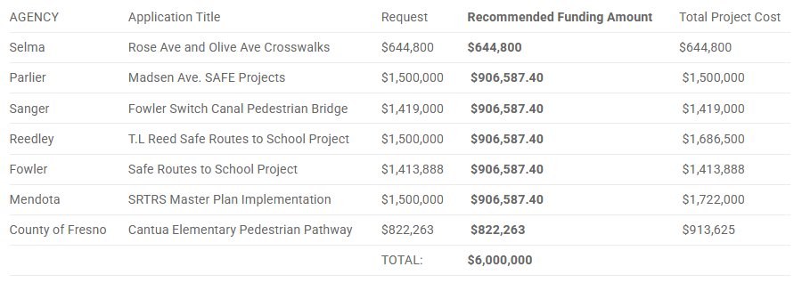

These seven projects recommended for funding are collectively serving 20 schools. More than half of the recommended projects involve pavement installation, upgrading from dirt pathways for routes to school. Due to the overwhelming number of projects submitted and limited funding availability, the scoring committee requested that applications above a $1 million request be scaled down, and chose to distribute funding among seven of the nine jurisdictions that applied. The scoring committee emphasized the proximity and number of schools served, safety of children walking on paved walkways, favored traffic calming measures and project readiness.

Please contact Simran Jhutti at jhutti@fresnocog.org for any questions regarding this program.

Action: Staff and the SRTS scoring committee request TTC and PAC recommend the Policy Board approve funding recommendations for the Measure C SRTS program.

- Simran Jhutti (FCOG) reported on the item.
- After an opportunity for public comment, Ms. Zieba (Reedley) motioned, and Mr. Gonzalez (Mendota) seconded to approve the item as presented.

All in Favor, no opposed.
Motion passed.

- TIFIA Funding Apportionment - Supplementary Funding Recommendations (Blake Rincon) [ACTION]
Summary: Congress is transferring unused funding from the Transportation Infrastructure Finance and Innovation Act (TIFIA) Program into the Surface Transportation Block Grant (STBG) Program for reallocation.

The funds distributed to California were pursuant to the Fiscally Responsible Highway Funding Act of 2024 (FRHFA). Attached is the FHWA notice for distribution of these funds. These apportionments are new and are available for regions to use on STBGP eligible-type projects. The process for using the apportionment is similar to the STBG apportionment given to our member agencies. Caltrans District 6 is aware of these funds, and understands the process for the request for reimbursement (RFA) submittals and reporting to be the same. The total amount distributed to Fresno COG is $1,503,976.

Fresno COG staff has determined that the most responsible methodology for distributing these funds is to refer to the latest STBG call-for-project’s contingency list. When analyzing the final cumulative score sheet, staff chose the next two highest scoring projects, as determined by our selected evaluators, to receive the new TIFIA funds. These two projects are the City of Sanger’s “Academy Avenue Rehabilitation – 4th Street to California Avenue” and the City of Mendota’s “Smoot Avenue Improvements.” The two respective projects applied for a combined total of $1,500,815 of STBG funds. These funds, when converted into the TIFIA apportionment, will use nearly 100% of the total distribution.

To receive these funds, Fresno COG staff asks that the above-named agencies comply with the set obligation deadlines, and that all funds be obligated by Sept. 30, 2028, or risk forfeiture. Therefore, staff convened with both member agencies to confirm that all phases of their projects were programmed by or before the 2027/28 fiscal year, and that each member agency was in good financial standing to deliver the 11.47% federal match requirements.

Staff has also asked each member agency to subsequently provide a city council-approved resolution before the Dec. 31, 2025 stating that participants agree to the above-named terms.

Action: Staff requests that TTC/PAC recommend that the Policy Board approve funding of the City of Sanger’s “Academy Avenue Rehabilitation – 4th Street to California Avenue” and the City of Mendota’s “Smoot Avenue Improvements” projects using new TIFIA programming, mirroring an STBG allocation of $1,500,815, before the conclusion of FFY 2027/2028.

- Blake Rincon (FCOG) reported on the item.
- After an opportunity for public comment, Mr. Gonzalez (Mendota) motioned, and Mr. Haussler (Clovis) seconded to approve the item as presented.

All in Favor, no opposed.
Motion passed.

- 2026 Measure C Statistically Valid Survey Results (Robert Phipps) [INFORMATION]
Summary: As part of the 2026 Measure C renewal effort, Fresno COG contracted with Fairbanks, Maslin, Maullin, Metz & Associates (FM3) for two statistically valid surveys of likely votes throughout the Fresno region. The first survey, conducted Oct. 9-20, included 1,600 voters with a base sample of 783 respondents in the urban area and an oversampling of 877 in the smaller, rural communities outside of Fresno and Clovis.

The survey focused primarily on support for continuing Measure C and the top transportation priorities for Fresno County’s residents.

Representatives with FM3 will offer a presentation on the results of that survey.

Action: Information and discussion. The Committee may provide additional direction at its discretion.

- Robert Phipps (FCOG) reported on the item.
- Adam Sonanshein presented a PowerPoint presentation.

Information item. No action needed.

- 2026 Measure C General Category Allocations and Term Recommendation (Robert Phipps) [ACTION]
Summary: At its Nov. 6 meeting, 28 of 30 voting members of the Measure C Steering Committee, or 93 percent of the membership, approved the “High-Priorities” option for apportioning future Measure C funding across five broad categories.

The “High-Priorities” option was based on a previous, initial vote that committee members approved, and that incorporated input from the Fresno COG Policy Board, city staff and elected officials, public comments, surveys and other stakeholders.

Under the recommendation, the 2026 Measure C ballot proposal would include five categories of expenditures:

Existing Neighborhood Streets and Roads: 65 percent $4,809,098,575
Public Transportation: 25 percent $1,849,653,297
Regional Connectivity: 5 percent $369,930,660
Transportation Innovation: 4 percent $295,944,528
Administration: 1 percent $73,986,132
The Public Transportation category would be split based on a population formula among the region’s three transit operators – Fresno Area Express, Clovis Transit and the Fresno County Rural Transit Agency.

Public transportation has consistently been listed as the No. 2 transportation issue in the county. The 25 percent recommendation represents an overall 1 percent increase in transit spending across the region and is intended to allow for greater expansion and coordination of the countywide transit system, including an expansion of Bus Rapid Transit and on-demand types of service, particularly in denser urban areas.

The Regional Connectivity category includes funding for capital improvements such as major arterial roadways and highway/freeway interchanges.

Transportation Innovation anticipates funding for additional infrastructure to address electric vehicle charging stations, electric grid expansion and battery storage, autonomous vehicles and zero or reduced transit fares for senior citizens, active military, veterans, and disabled populations.

The 1 percent administration set-aside includes costs associated with: staffing; annual audits; expenses related to the Measure C Oversight Committee; technical assistance to jurisdictions; public outreach and notifications for amendments to the expenditure plan; and a project database.

Previously, the Steering Committee had recommended that the Measure be approved as a 30-year extension of the current initiative.

Attached to this annotated report are the PowerPoint presentation the Steering Committee received, as well as handouts comparing the two options Committee members considered for the General Category Allocations and a side-by-side summary table comparing the two options against allocations in the current Measure.

Action: Staff and the Measure C Steering Committee request the TTC/PAC recommend the Policy Board approve the “High-Priorities” option for the 2026 Measure C General Category Allocations, and a 30-year extension timeline.

- Robert Phipps (FCOG) reported on the item.
- Discussion ensued.
- After an opportunity for public comment, Ms. Zieba (Reedley) motioned, and Mr. Nerland (Fresno County) seconded to approve the item with amendments to change the formula to 75/25.

Vote: 3 Yes, 7 No.
Motion Failed.

- Mr. Haussler (Clovis) motioned, and Mr. Henderson (Kingsburg) seconded to approve the item to include amendment to encourage mayors to discuss the 80/20 formula.

Vote: 5 Yes, 5 No.
Motion Failed.

- Ms. Cabrera (San Joaquin) motioned, and Mr. Mascia (City of Fresno) seconded to approve the action as presented.

Vote: 7 Yes, 3 No.
Motion Passed.

- ADMINISTRATIVE CONSENT ITEMS

- 2025 Fresno COG One Voice Advocacy Trip to Washington D.C. (Robert Phipps) [ACTION]

Summary: Fresno COG’s One Voice effort brings together multiple agencies, jurisdictions and transportation stakeholders to rally around an approved list of policy issues and/or funding requests. After a five-year hiatus, the One Voice effort was revived in 2024 with a public-private delegation visiting Congressional and Federal agency representatives in Washington, D.C. to pursue funding, grant opportunities and policy changes. One Voice delegates agreed that the advocacy trip was successful and should be scheduled annually.

With the Infrastructure Investment and Jobs Act (IIJA) expiring in September 2026, Fresno COG has an interest in advocating for continued Federal partnership and investment along a range of funding programs. Historically, local partnering agencies, including the Fresno County Economic Opportunities Commission, Workforce Development Board and Westlands Water District, have also expressed an interest in participating in the One Voice effort. However, staff seeks the Policy Board’s assistance in identifying regional transportation-related issues or projects that could be carried to D.C. next spring.

With anticipation, staff is developing a Regional Priority Submittal Form, which could be released to the public this month. Any public or private entity is welcome to submit a priority for consideration by the One Voice Steering Committee and the Fresno COG Policy Board. Submitting entities must commit to sending or assigning a representative to Washington D.C. with the delegation to speak on the priorities’ behalf. Staff proposes the trip be tentatively set for late spring 2025.

The 2024 Priorities Summary and additional trip information is available here: Fresno COG’s One Voice Webpage.

Action: Information and discussion

- Robert Phipps (FCOG) reported on the item.

Information item. No action needed.

- ADMINISTRATIVE ACTION/DISCUSSION ITEMS
- NONE

- OTHER ITEMS

- Items from Staff

- Robert Phipps (FCOG) – reminded members that there will be a meeting on December 12, 2025

- Items from Members

- PUBLIC PRESENTATIONS

- Public Presentations

- None.

VII. ADJOURNMENT

The meeting was adjourned at 12:08 p.m.

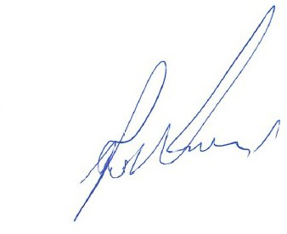
Respectfully submitted,

Robert Phipps, Executive Director

Public:

Staff:
Denise Flores, Robert Phipps, Paul Herman, Moses Stites, Ofelia Abundez, Janelle Del Campo, Les Beshears, Simran Jhutti, Pankaj Joshi, Rachel Hellet, Blake Rincon.

